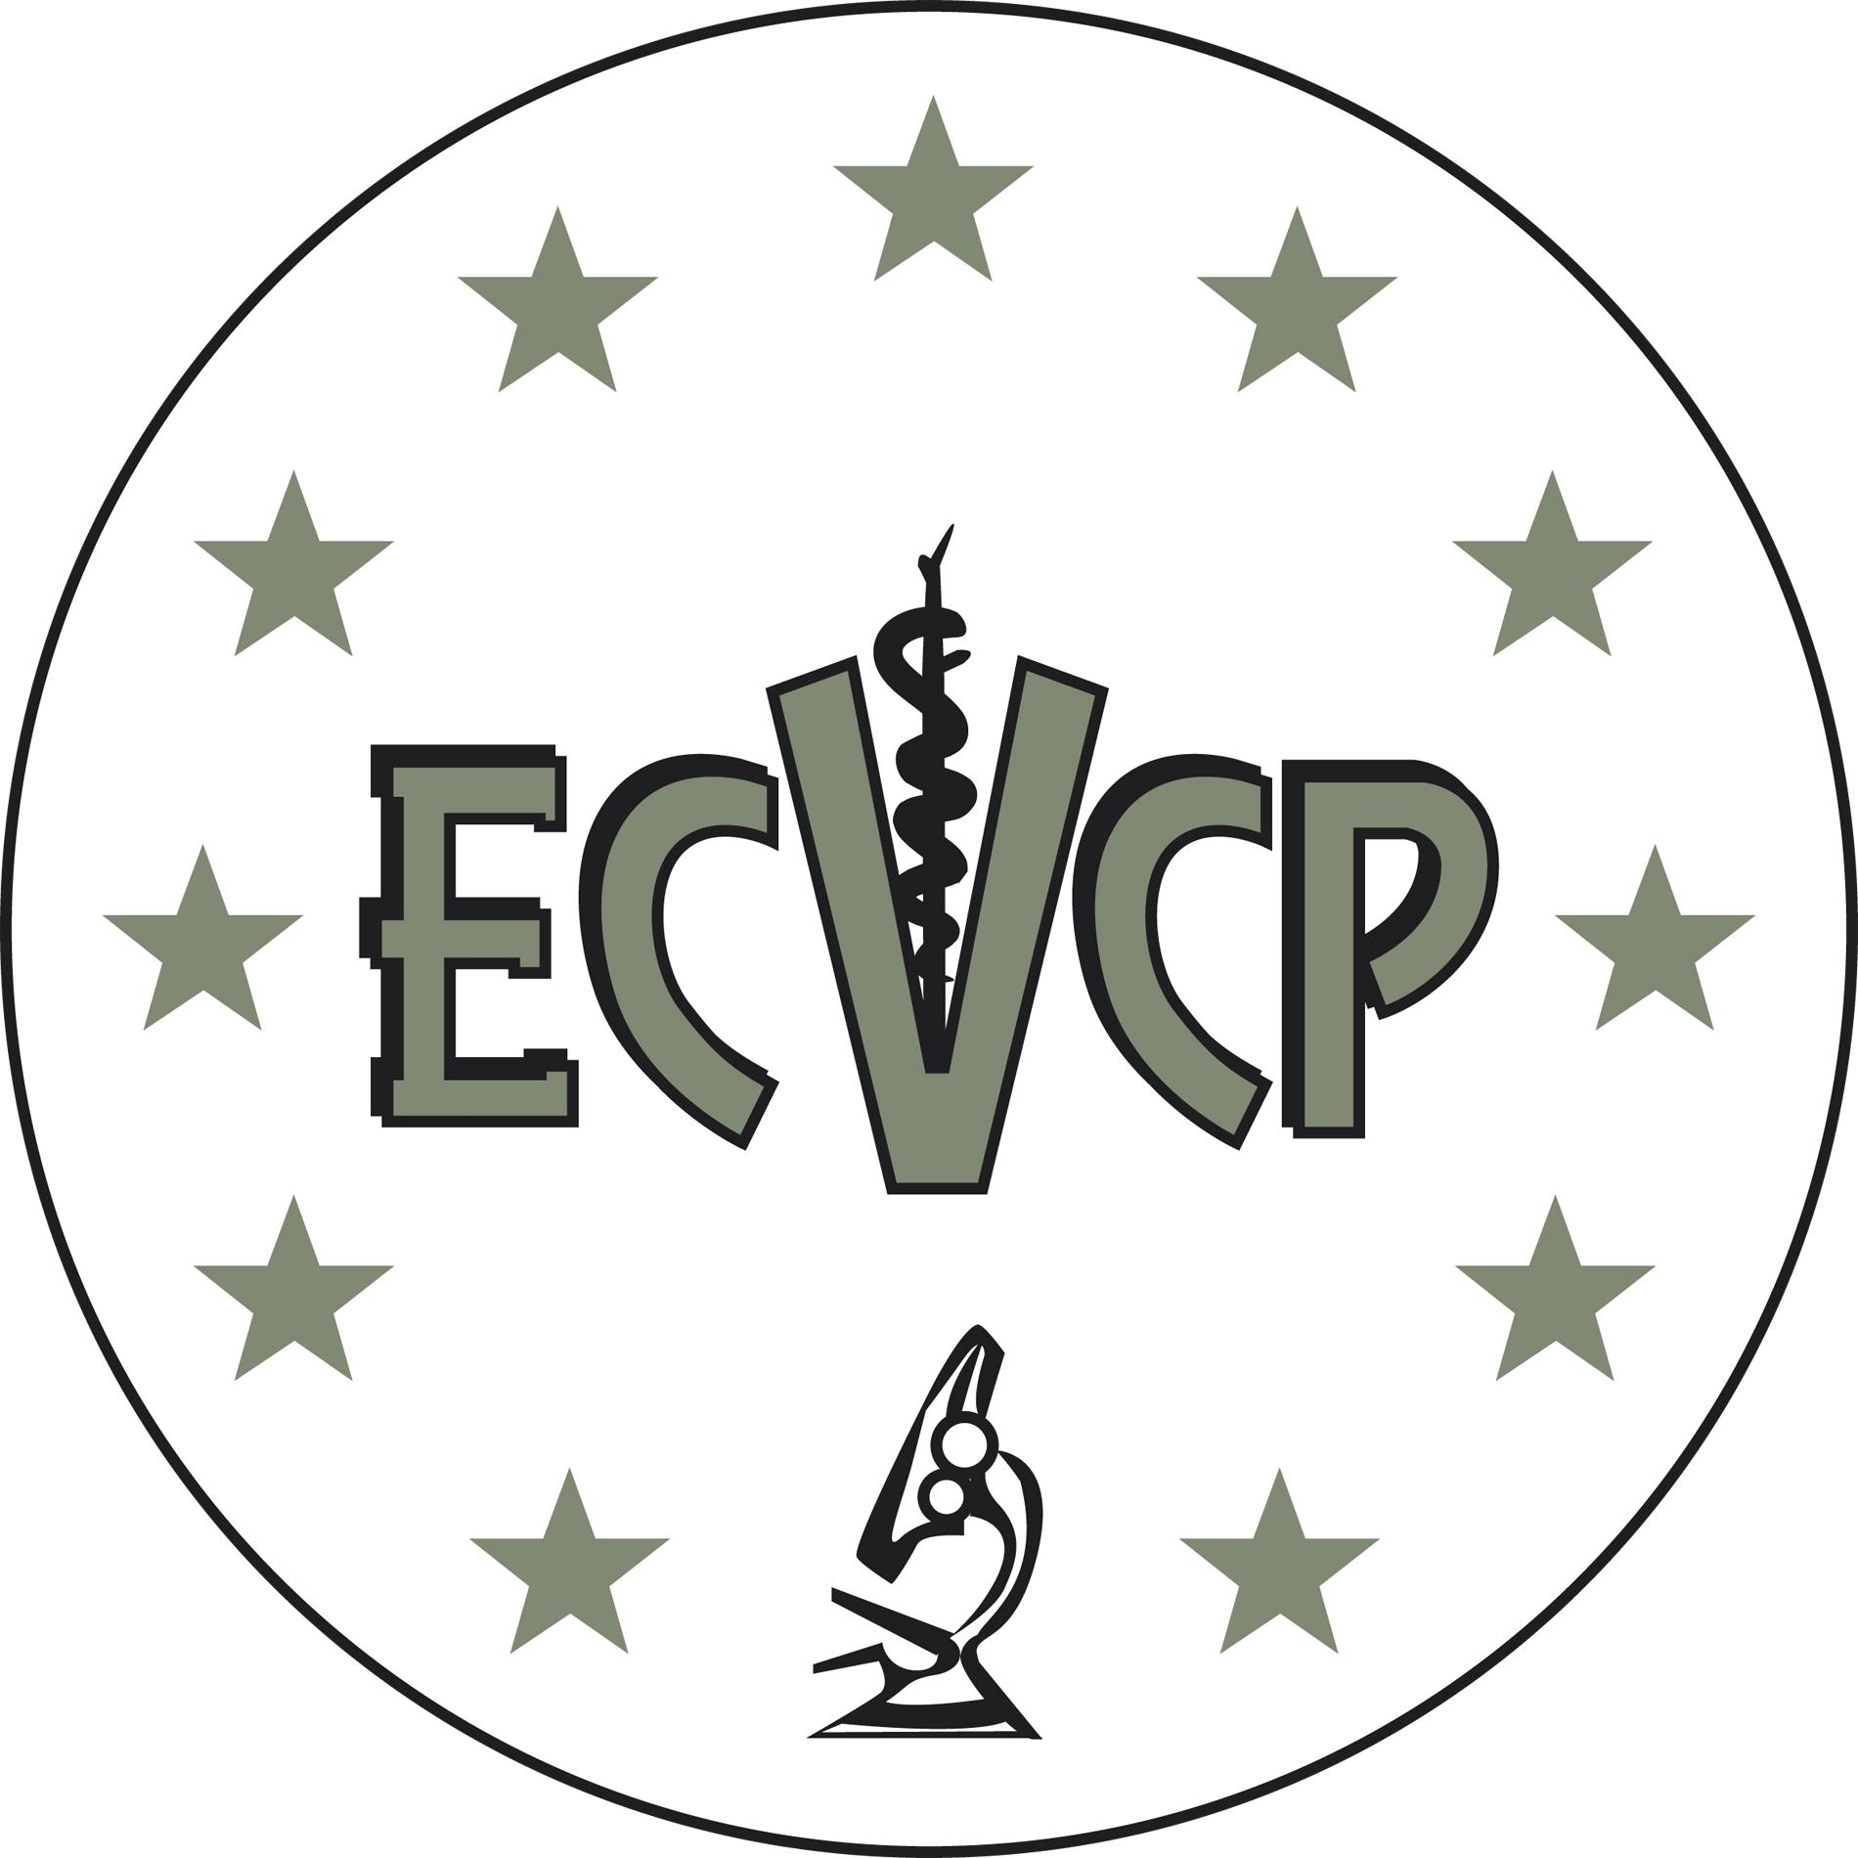

Letter from Programme Director for Application for the Phase 2 Examination
1.4.1.

Resident …………………………………………………………..

This is to confirm that the above Resident has completed their ECVCP approved Training Programme from ……………………….. to ………………………. (dates)
at …………………………………………………… (location).

The Training Programme was approved on ……................ (date) and the Laboratory was approved on …………………………….(date).

I certify that the Resident has been properly supervised according to the guidelines as stated in the Information Brochure.

I have ensured that the Resident has met regularly with their Resident Advisor and has had annual evaluations of his / her / their performance. I feel that the Resident has made sufficient progress to take the ECVCP Phase 2 Examination.

I have checked and verified the Annual Resident Logs and I can confirm that the Resident has properly and fully completed all the externships stated in the Activity Logs.

I am not aware of any evidence of misconduct that would affect the commitment of the Applicant to the constitutional objectives of the ECVCP or the moral or ethical standing of the Applicant within the veterinary profession.

I can confirm that I am an ECVCP or ACVP (Clinical Pathology) Diplomate with Active status.

Please print name: ______________________________________________
Job title _______________________________________________________
Date __________________________________________________________
Place: _________________________________________________________
Signed ________________________________________________________

