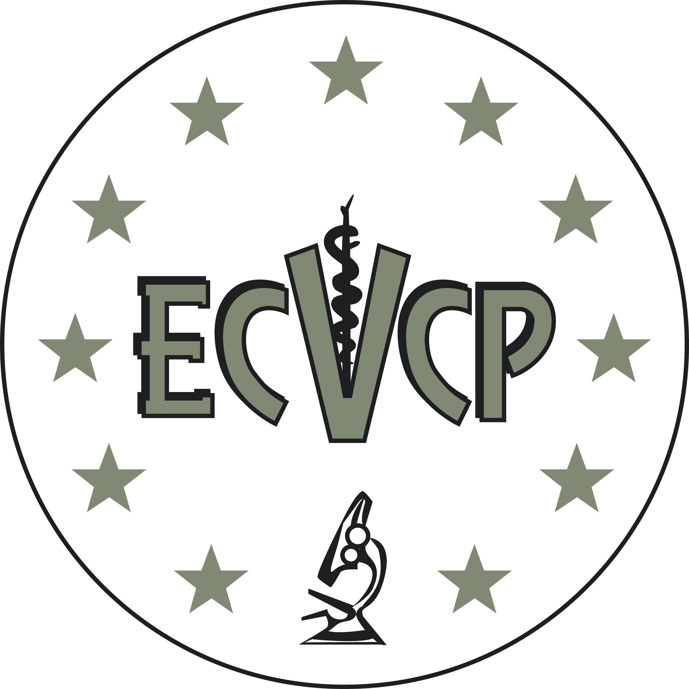

Letter from Programme Director for Application for the Phase 1 Examination
1.3.1.

Re: Resident …………………………………………………………

This is to confirm that the above Resident has completed 12 months of their ECVCP Approved Training Programme from ………………. to ………………….. (dates)
at ………………………………………………. (location).

The Training Programme was approved on ……............(date) and the Laboratory was
approved on ………………….. (date).

I certify that the Resident has been properly supervised according to the guidelines as stated in the Information Brochure.
I have ensured that the Resident has met regularly with their Resident Advisor and has had an annual evaluation of his / her / their performance. I feel that the Resident has made sufficient progress to take the ECVCP Phase 1 Examination.

I can confirm that a Proctor, as named in the Phase 1 Examination Application Form, will physically accompany the Candidate at all times during the Phase 1 Examination. I am confident that the Proctor will be impartial when performing this duty, even if the Candidate is previously known to them.

I am not aware of any evidence of misconduct that would affect the commitment of the Applicant to the constitutional objectives of the ECVCP or the moral or ethical standing of the Applicant within the veterinary profession. I can confirm that I am an ECVCP or ACVP (Clinical Pathology) Diplomate with Active status.

Please print name: _____________________________________________________
Job title ______________________________________________________________
Date _________________________________________________________________
Place: ________________________________________________________________
Signed _______________________________________________________________

